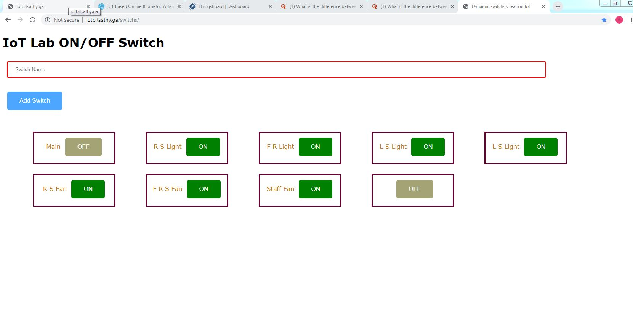IoT Lab Automation

Website Links:

1. <http://iotbitsathy.ga/switchs/> ------Switch

2. <http://iotbitsathy.ga/> ----Water Tank Level